LAB 1A- Packet Tracer - Navigating the IOS

1. Topology

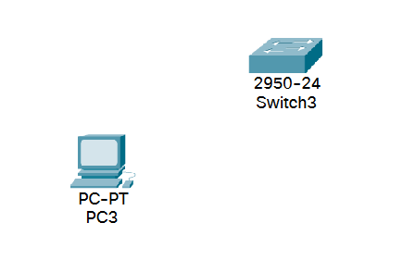

1. Objectives

Part 1: Basic Connections, Accessing the CLI and Exploring Help

Part 2: Exploring EXEC Modes

Part 3: Setting the Clock

1. Background

In this activity, you will practice skills necessary for navigating the Cisco IOS, including different user access modes, various configuration modes, and common commands you use on a regular basis. You also practice accessing the context-sensitive Help by configuring the **clock** command.

1. Basic Connections, Accessing the CLI and Exploring Help

In Part 1 of this activity, you connect a PC to a switch using a console connection and explore various command modes and Help features.

* 1. Connect PC3 to S3 uses a console cable.
     1. Click the **Connections** icon (the one that looks like a lightning bolt) in the lower left corner of the Packet Tracer window.
     2. Select the light blue Console cable by clicking it. The mouse pointer will change to what appears to be a connector with a cable dangling off of it.
     3. Click **PC3**; a window displays an option for an RS-232 connection.
     4. Drag the other end of the console connection to the S3 switch and click the switch to bring up the connection list.
     5. Select the Console port to complete the connection.
  2. Establish a terminal session with S3.
     1. Click **PC3** and then select the **Desktop** tab.
     2. Click the **Terminal** application icon; verify that the Port Configuration default settings are correct.

What is the setting for bits per second? __**9600**_____

* + 1. Click **OK**.
    2. The screen that appears may have several messages displayed. Somewhere on the display there should be a Press RETURN to get started! message. Press **ENTER**.

What is the prompt displayed on the screen? ___**Switch>**______

* 1. Explore the IOS Help.
     1. The IOS can provide help for commands depending on the level being accessed. The prompt currently being displayed is called **User EXEC** and the device is waiting for a command. The most basic form of help is to type a question mark (?) at the prompt to display a list of commands.

S3> **?**

Which command begins with the letter ‘C’? ______**connect**_______

* + 1. At the prompt, type **t**, followed by a question mark (**?**).

S3> **t?**

Which commands are displayed? _______**telnet, terminal, and traceroute**_______________

* + 1. At the prompt, type **te**, followed by a question mark (**?**).

S3> **te?**

Which commands are displayed? _____ **telnet and terminal** ______________

This type of help is known as **context-sensitive** Help, providing more information as the commands are expanded.

1. Exploring EXEC Modes

In Part 2 of this activity, you switch to privileged EXEC mode and issue additional commands.

* 1. Enter privileged EXEC mode.
     1. At the prompt, type the question mark (**?**).

S3> **?**

What information is displayed that describes the **enable** command? **_____”Turn on privileged commands”_________**

* + 1. Type **en** and press the **Tab** key.

S3> **en<Tab>**

What displays after pressing the **Tab** key? ___**enable**___

This is called command completion or tab completion. When part of a command is typed, the **Tab** key can be used to complete the partial command. If the characters typed are enough to make the command unique, as in the case with the **enable** command, the remaining portion is displayed.

What would happen if you were to type **te<Tab>** at the prompt?

**nothing because te can complete to either telnet or terminal, so the computer won’t autofill since it doesn’t know which one you want**

____________________________________________________________________________________

____________________________________________________________________________________

* + 1. Enter the **enable** command and press **ENTER**. How does the prompt change?

______**it goes from Switch> to Switch#**

* + 1. When prompted, type the question mark (**?**).

S3# **?**

Previously there was one command that started with the letter ‘C’ in user EXEC mode. How many commands are displayed now that privileged EXEC mode is active? (**Hint**: you could type c? to list just the commands beginning with ‘C’.)

______**There are 5 unique commands now**

* 1. Enter Global Configuration mode.
     1. One of the commands starting with the letter ‘C’ is **configure** when in Privileged EXEC mode. Type either the full command or enough of the command to make it unique along with the <**Tab**> key to issue the command and press **<ENTER>**.

S3# **configure**

What is the message that is displayed?

**“Configuring from terminal, memory, or network [terminal]?”**

* + 1. Press the **<ENTER>** key to accept the default parameter enclosed in brackets **[terminal]**.

How does the prompt change? __**It now shows Switch(config)#**______________________________

* + 1. This is called global configuration mode. This mode will be explored further in upcoming activities and labs. For now exit back to Privileged EXEC mode by typing **end**, **exit** or **Ctrl-Z**.

S3(config)# **exit**

S3#

1. Setting the Clock
   1. Use the clock command.
      1. Use the **clock** command to further explore Help and command syntax. Type **show** **clock** at the privileged EXEC prompt.

S3# **show clock**

What information is displayed? What is the year that is displayed?

__**the current date and time according to the switch. the year presented is 1993**

* + 1. Use the context-sensitive Help and the **clock** command to set the time on the switch to the current time. Enter the command **clock** and press **ENTER**.

S3# **clock<ENTER>**

What information is displayed? **____”% Incomplete command.”**

* + 1. The % Incomplete command message is returned by the IOS indicating that the **clock** command needs further parameters. Any time more information is needed help can be provided by typing a space after the command and the question mark (?).

S3# **clock ?**

What information is displayed? **it only has one command “set Set the time and date”**

* + 1. Set the clock using the **clock set** command. Continue proceeding through the command one step at a time.

S3# **clock set ?**

What information is being requested? __**it requests “hh:mm:ss Current Time”**

What would have been displayed if only the **clock set** command had been entered and no request for help was made by using the question mark? **It would make an error since no data was entered and the command parameters require that data with the hh:mm:ss format be entered in when using the command.**

* + 1. Based on the information requested by issuing the **clock set ?** command, enter a time of 3:00 p.m. by using the 24-hour format of 15:00:00. Check to see if further parameters are needed.

S3# **clock set 15:00:00 ?**

The output returns the request for more information:

<1-31> Day of the month

MONTH Month of the year

* + 1. Attempt to set the date to 01/31/2035 using the format requested. It may be necessary to request additional help using the context-sensitive Help to complete the process. When finished, issue the **show clock** command to display the clock setting. The resulting command output should display as:

S3# **show clock**

*15:0:4.869 UTC Tue Jan 31 2035

* + 1. If you were not successful, try the following command to obtain the output above:

S3# **clock set 15:00:00 31 Jan 2035**

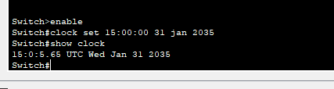

**Note: To save the configuration you need to use the command “Write” or “Copy running-config startup-config” in the Exec mode.**

* 1. Explore additional command messages.
     1. The IOS provides various outputs for incorrect or incomplete commands as experienced in earlier sections. Continue to use the **clock** command to explore additional messages that may be encountered as you learn to use the IOS.
     2. Issue the following command and record the messages:

S3# **cl**

What information was returned? **“% Ambiguous command: “cl””**

S3# **clock**

What information was returned? **“% Incomplete command.”**

S3# **clock set 25:00:00**

What information was returned?

**It reported and invalid input and pointed at the first number for the time set. This is because 25 is outside of the 24 hour range and it would be impossible to set the clock to that time.**

_____________________________________________________________________________

S3# **clock set 15:00:00 32**

What information was returned?

**There was a very similar error to what the previous command outputted, but it instead pointed at the 32 since there is no possible month that could have a 32nd day, so therefore that number is impossible to have for the clock.**

______________________________________________________________________________________

1. Suggested Scoring Rubric

|  |  |  |  |
| --- | --- | --- | --- |
| Activity Section | Possible Points | | Earned Points |
| Part 1: Basic Connections, Accessing the CLI and Exploring Help | | **20** |  |
| Part 2: Exploring EXEC Modes | | **20** |  |
| Part 3: Setting the Clock | | **10** |  |
| **Total Score** | **50** | |  |

IT 341

Lab 1B- 50 Points

LAB 1B: CONNECTING DEVICES

**Topology Diagram:**

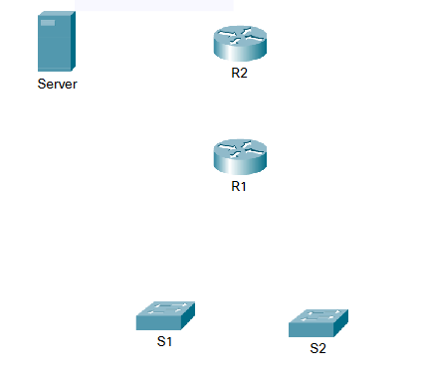

|  |  |  |  |  |
| --- | --- | --- | --- | --- |
| Devices | Interfaces | IP Address | Subnet Mask | Default Gateway |
| R2 | F0/0 | 192.168.254.253 | 255.255.255.0 | N/A |
|  | S0/1/0 | 10.10.10.1 | 255.255.255.252 | N/A |
| R1 | S0/1/0 | 10.10.10.2 | 255.255.255.252 | N/A |
|  | F0/0 | 172.16.1.1 | 255.255.255.0 | N/A |
|  | F0/1 | 172.16.2.1 | 255.255.255.0 | N/A |
| PC1 | NIC | 172.16.1.2 | 255.255.255.0 | 172.16.1.1 |
| PC2 | NIC | 172.16.2.2 | 255.255.255.0 | 172.16.2.1 |
| Server | NIC | 192.168.254.254 | 255.255.255.0 | 192.168.254.253 |

**LEARNING OBJECTIVES:**

* Connect the devices in the standard lab setup
* Connect the devices
* Verify connectivity
* View the standard lab setup in the Physical Workspace
* Enter and view the Physical Workspace
* View the standard lab setup at the various levels of the Physical Workspace

**INTRODUCTION:**

When working in Packet Tracer, in a lab environment, or in a corporate setting it is important to know how to select the proper cable and how to properly connect devices. This activity will examine device configurations in Packet Tracer, selecting the proper cable based on the configuration, and connecting the devices. This activity will also explore the physical view of the network in Packet Tracer

### Task 1: Connect the devices in the standard lab setup

#### **Step 1 – Connect the devices** – **25 Points**

1. Connect PC 1 to the last port of switch S1 and PC 2 to the last port on switch S2 using the proper cable.
2. Click on router R1 and examine the configuration using the **Config** tab. Connect the proper interface on the router to Interface FastEthernet0/0 on switch S1 using the proper cable.
3. Connect the proper interface on the router to Interface FastEthernet0/1 on switch S2 using the proper cable.
4. Click on both routers and examine the configuration using the **Config** tab. Connect the routers together using the proper interfaces and the proper cable.
5. Click on router R2 and examine the configuration using the **Config** tab. Connect the proper interface on the router to the proper interface on Server using the proper cable.

#### **Step 2 – Verify connectivity- 15 Points**

#### From the Command Prompt on the Desktop of both PCs issue the command ping 192.168.254.254, the IP address of Server. If the pings fail, check your connections and troubleshoot until the pings succeed. Check your configuration by clicking the Check Results button.

### Task 2: View the standard lab setup in the Physical Workspace- 5 Points

### *Step 1 -* *Enter and view the Physical Workspace*

Most of our work in Packet Tracer has been done in the Logical Workspace. In an internetwork, routers may be in different sites from across the street to across the globe. The serial link between the routers represents a dedicated leased line between two locations consisting of a DTE (Data Terminal Equipment), such as a router, connected to a DCE (Data Communication Equipment), such as a CSU/DSU or modem. The DCE connects to a service provider's local loop and the connections are repeated at the other end of the link. The Physical Workspace allows us to see these relationships more clearly.   
  
Enter the Physical Workspace by clicking the tab in the upper left hand corner of the Workspace.

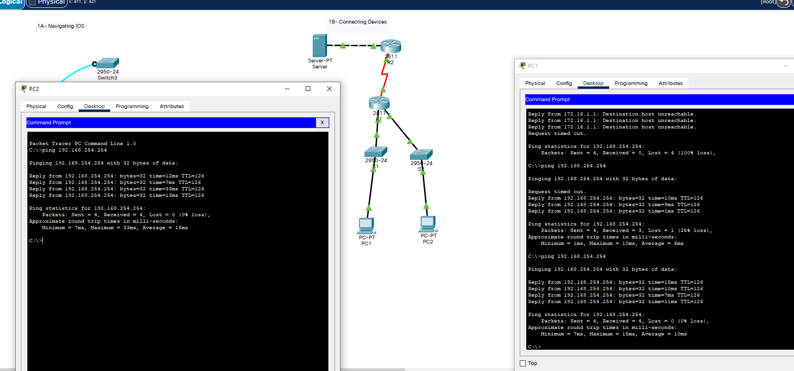

**Reflection: 5 Points**

Do you know the difference between a physical topology and a logical topology? How are each used? How would you view each topology in Packet Tracer?

**The difference between a physical topology and logical topology is that the physical topology represents the physical hardware such as network switches and servers, where as the logical topology shows the data flow between the physical hardware. You view the physical topology with the servers, routers, cables, switches, etc. and the logical is shown with the command prompt and packet routing.**